CONFIDENTIAL CS/OCT 2026/MAT133

UNIVERSITI TEKNOLOGI MARA FINAL EXAMINATION

COURSE
COURSE CODE
EXAMINATION TIME
PRE CALCULUS
MAT133 OCTOBER 2026
2 HOURS

INSTRUCTIONS TO CANDIDATES

- This question paper consists of 5 questions.

- Answer ALL questions in the Answer Booklet. Start each answer on a new page.

- Do not bring any material into the examination room unless permission is given by the invigilator .
- Please check to make sure that this examination pack consists of: i) the Question Paper
  - a one - page Append ix 1
  - an Answer Booklet - provided by the Faculty
  - a graph paper - provided by the Faculty

- Answer ALL questions in English.

/

DO NOT TURN THIS PAGE UNTIL YOU ARE TOLD TO DO SO

This examination paper consists of 6 printed pages

QUESTION 1
a) Solve the inequality 3x² - 9x - 12 > 0.
(5 marks)
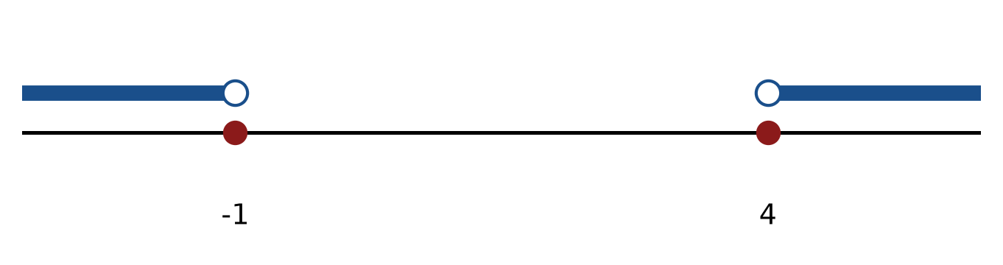
Figure: critical values.
b) Solve the inequality |4 - x| < 2. Express the answer in interval notation and on a number line.
(5 marks)
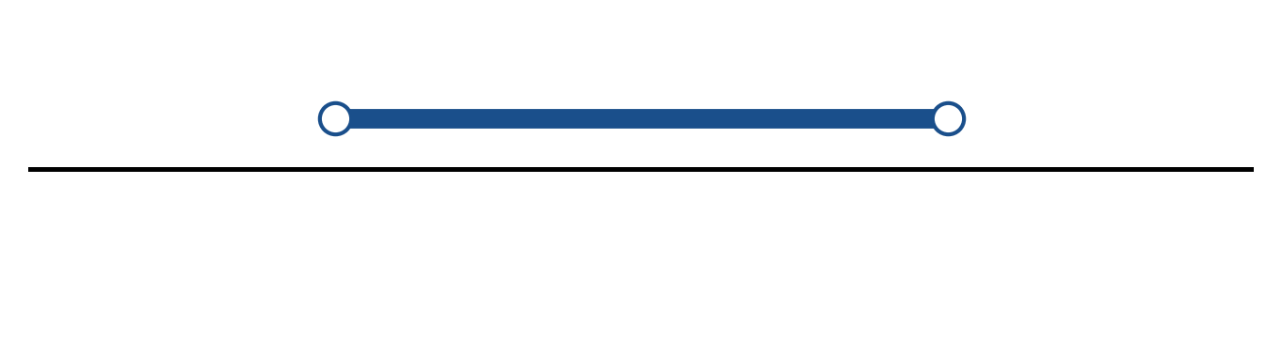
Figure: solution on a number line.
c) Solve the equation |2x + 6| = 4.
(4 marks)
QUESTION 2
a) Given f(x) = 2x + 2 and g(x) = 5 - 4x, find (f + g)(x), (f - g)(x) and (f g)(x). State the domain of each.
(4 marks)
b) Given f(x) = x + 1 and g(x) = 2/(x + 4), find (g ∘ f)(x) and state its domain.
(5 marks)
c) Write the equation of the circle with centre (5, -3) and radius 5. Hence write its general equation and sketch the circle.
(5 marks)
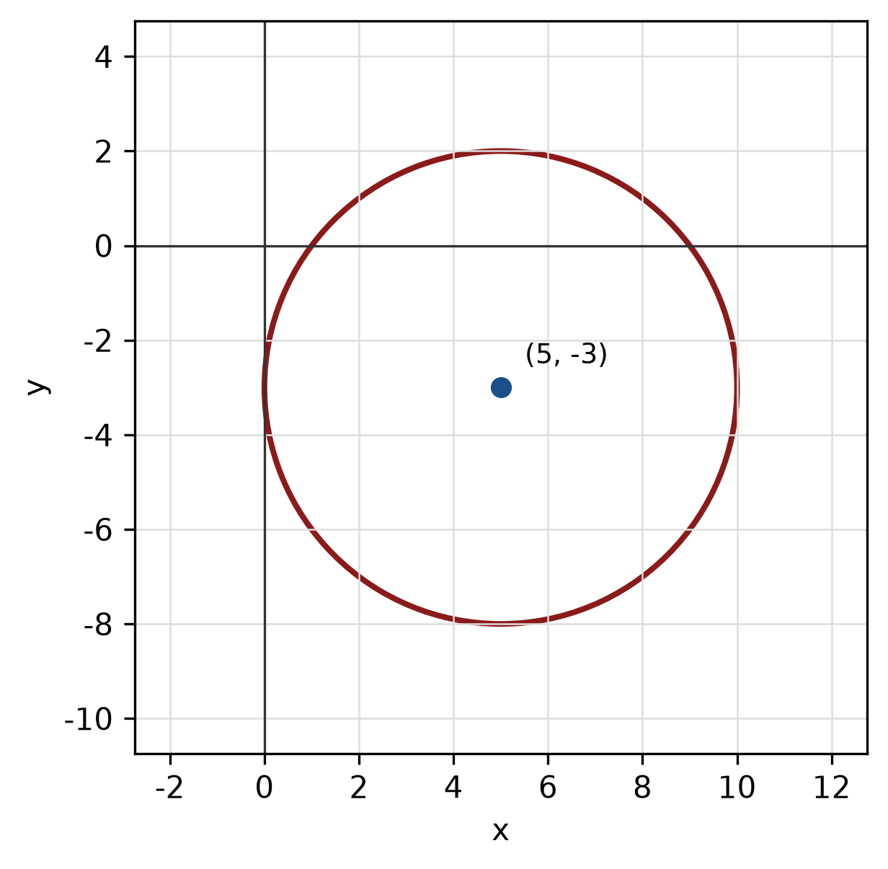
Figure: circle.
QUESTION 3
a) Given z₁ = -6 + 6i and z₂ = -6 + 6i, find z₁ + z₂ in the form a + bi.
(4 marks)
b) Evaluate i^28 and simplify completely.
(3 marks)
c) Solve the exponential equation 3^(-2x - 5) = 3^(x - 2).
(5 marks)
QUESTION 4
a) Solve the system of equations simultaneously:
x - 3y - 3z = 0
3x - y - 4z = 4
-x - y - z = 4
(5 marks)
b) Solve the simultaneous equations
2x - 2y = -12
-4x + 3y = 19.
(4 marks)
c) Write x² - 4x + y² + 6y - 12 = 0 in standard form. Hence state the centre and radius and sketch the circle.
(5 marks)
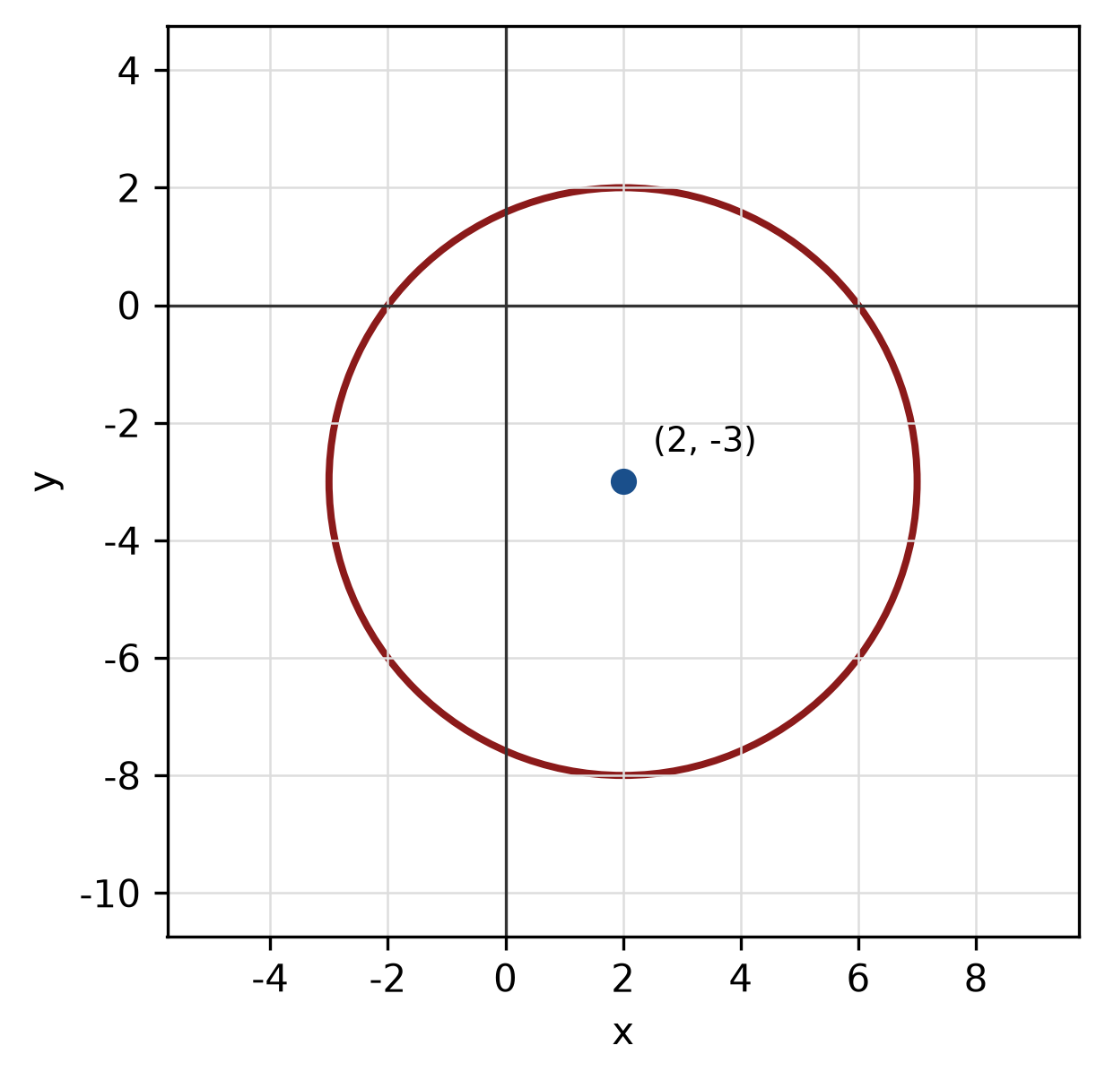
Figure: circle.
QUESTION 5
a) Prove the identity (1 + cos x)/sin x + sin x/(1 + cos x) = 2 csc x.
(5 marks)
b) A circle has radius 11 cm. Find the length of the arc subtended by a central angle of 150°.
(4 marks)
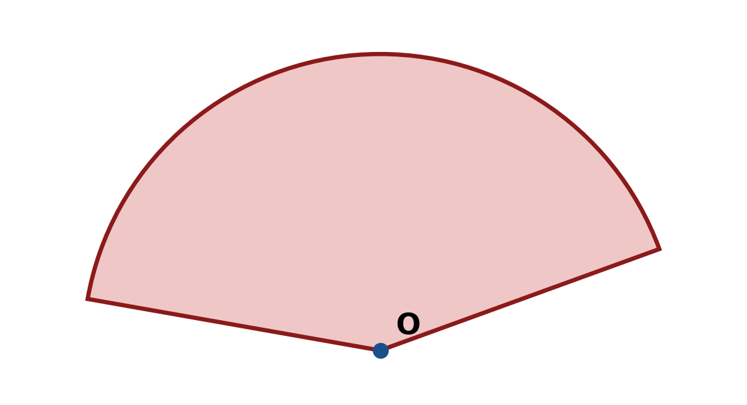
Figure: arc and sector.
c) Solve the triangle with sides a = 10 cm, b = 24 cm and c = 26 cm. Find all three angles.
(5 marks)
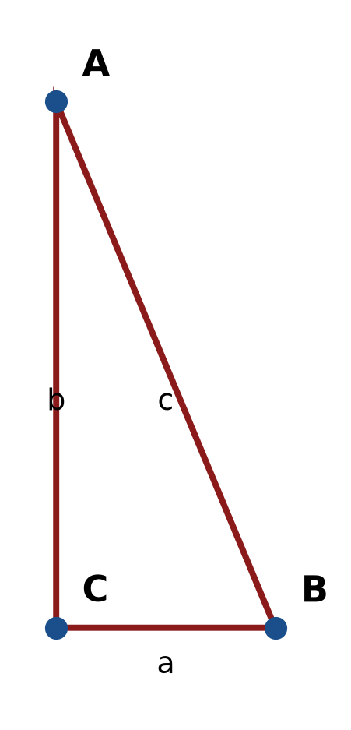
Figure: right triangle.
END OF QUESTION PAPER

APPENDIX 1
Formula sheet (as supplied with the paper).
sin² A + cos² A = 1 | tan² A + 1 = sec² A
sin(A + B) = sin A cos B + cos A sin B | tan 2A = 2 tan A / (1 − tan² A)
cos(A + B) = cos A cos B − sin A sin B | Arc length, s = rθ
tan(A − B) = (tan A − tan B) / (1 + tan A tan B) | Area of sector = ½r²θ
cos 2A = cos² A − sin² A | a / sin A = b / sin B = c / sin C
cos 2A = 1 − 2sin² A = 2cos² A − 1 | a² = b² + c² − 2bc cos A
sin 2A = 2 sin A cos A | Area of triangle = ½ab sin C

